Chicken Salad
RECIPE
INGREDIENTS
- 12 cups cooked pulled chicken
- 3 cups chopped celery
- 1-1 ½ cups raisins
- 6 green onions, thinly sliced
- 3 cup mayonnaise
- ¾ cup sour cream
- Salt and pepper
- 1 tablespoon dried dill
- juice of 3 small lemons
- 24 rolls
- 24 lettuce leaves
- Optional Ingredients:
Red or green grapes, nuts, parsley, milk, red bell pepper, red onion, apple, craisins, sweet pickles or relish, dill pickles or relish

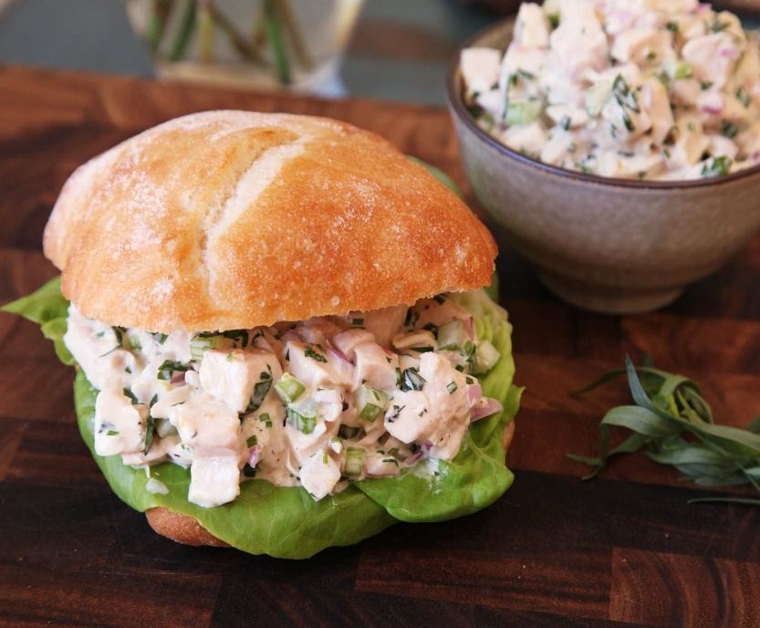

DIRECTIONS
- Add the chicken, celery, raisins and green onion to a large bowl. Toss to combine. Set bowl aside.
- In a small bowl, add the mayonnaise, sour cream, pepper, salt, dill and lemon juice. Whisk together until combined. Pour the dressing over the chicken mixture. Stir until combined.
- Cover and refrigerate 6 hours or overnight.
- Slice each roll in half. Place a lettuce leaf on bottom half. Scoop 1/2 cup of chicken salad over bottom half. Top with the other half of roll.

Prep Time: 30 minutes | Cook Time: 0 minutes | Total Time: 30 minutes | Yield: 24 servings

