Chicken Picata
RECIPE
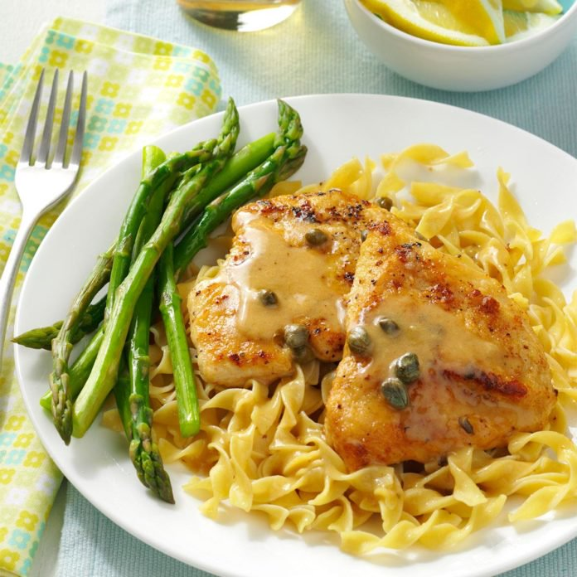
INGREDIENTS
- 20 chicken breasts (4oz)
- Salt and pepper
- 2 ½ cups flour
- Oil
- 5 cups chicken stock
- ¼ cup capers
- 2/3 cups lemon juice
- 2 sticks butter
- Optional Ingredients:
Fresh parsley

DIRECTIONS
- Preheat oven to 350°. Spray a 2” pan with non-stick spray.
- Pound chicken thin and sprinkle chicken with salt and pepper.
- Place flour in a shallow bowl. Dip chicken in flour to coat both sides; shake off excess.
- In a large skillet, heat some oil over medium-high heat. Brown chicken in batches, adding additional oil as needed. Transfer chicken to prepared pan.
- Add stock, capers and lemon juice to skillet, stirring to loosen browned bits from pan. Whisk in butter, 1 tablespoon at a time, until creamy. Pour sauce over chicken. Cover and bake 20-30 minutes or until no longer pink or internal temperature reaches 165 degrees.

Prep Time: 20 minutes | Cook Time: 50 minutes | Total Time: 70 minutes | Yield: 20 servings

