Chicken Parmesan
RECIPE
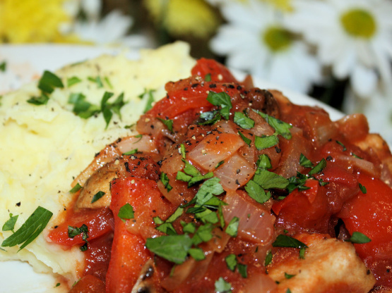

DIRECTIONS
- Preheat oven to 350 degrees. Spray baking sheet with non-stick spray.
- Place chicken between plastic wrap and tenderize using a meat tenderizer
- Mix bread crumbs, parmesan, 1 tablespoon parsley, Italian seasoning, garlic powder, onion powder, salt and pepper in a bowl and set aside. In a separate bowl, beat eggs until creamy.
- In a large pan, add oil and allow to preheat on medium to medium-high heat.
- Bread chicken breasts by pressing breast into flour, then in egg wash, and finally in bread crumb mixture coating both sides well in each step. Place breaded chicken in pan in small batches and cook until golden brown. Then turn and cook the other side until golden.
- Place cooked chicken breasts on prepared baking sheet. Spoon approx. 1/3 cup sauce over each breast and top with ¼ cup mozzarella cheese. Sprinkle small amount of parsley on cheese and place in preheated oven to melt the cheese. Bake for 30-40 minutes until cheese has melted and chicken reaches an internal temperature of 165 degrees.

INGREDIENTS
- 20 chicken breasts (4oz)
- 2 ½ cups flour
- 8 eggs
- 6 cups bread crumbs
- 2 cups parmesan cheese
- 4 teaspoons parsley
- 1 tablespoon Italian seasoning
- 1 tablespoon garlic powder
- 1 tablespoon onion powder
- Salt and pepper
- 1 can (#10) pasta sauce
- 5 cups mozzarella cheese, shredded
- Optional Ingredients:
Fresh parsley, basil, rosemary, oregano

Prep Time: 15 minutes | Cook Time: 50 minutes | Total Time: 65 minutes | Yield: 20 servings

