Chicken Hobo Pack
RECIPE
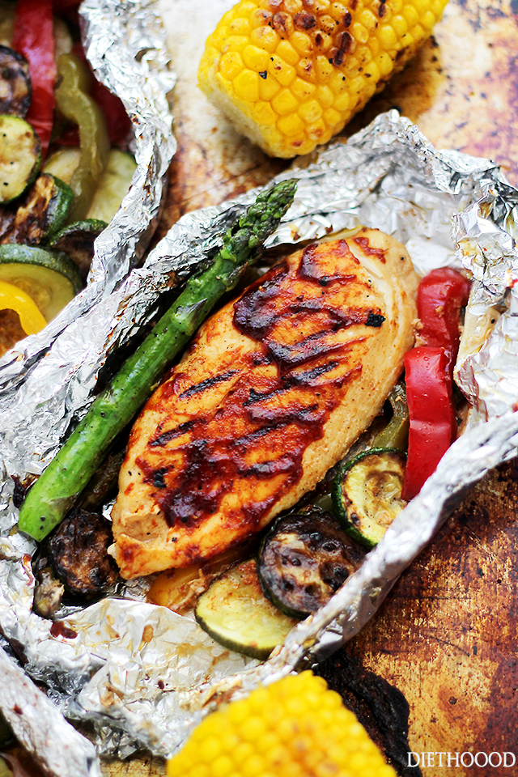
INGREDIENTS
- 20 fully cooked grilled chicken fillets, frozen
- 2 cups BBQ sauce
- 10 cups rosemary potatoes
- 20 cups vegetable
- Phase & Chef Shake

Note: This is just an example of the type of hobo pack you can create. The Sweet-N-Sour Sauce along with fried rice or grains & kale would also make a great meal. Be creative!

DIRECTIONS
- Tear off a large square of aluminum foil.
- Place ½ cup rosemary potatoes in center of foil. Lay chicken on top of potatoes.
- Place a small amount of BBQ sauce on chicken. Place 1 cup of vegetables around the edges of the chicken.
- Season vegetables with Phase/Chef Shake mixture. Seal foil package securely and freeze.
- When ready to heat and serve, preheat oven to 350 degrees. Bake for 20-25 minutes or until internal temperature reaches 165 degrees.

Prep Time: 20 minutes | Cook Time: 20-25 minutes | Total Time: 40-45 minutes | Yield: 20 servings

