Chicken Fajitas
RECIPE
INGREDIENTS
- 1 (5#) bag of chicken fajita breast strips
- 2 cups chicken stock
- 2-3 tablespoons of oil
- 3 large onions sliced
- 3 red peppers, sliced in strips
- 3 green peppers, sliced in strips
- Salt and pepper
- 20 tortillas
- Shredded cheese, sour cream and salsa
- Optional Ingredients:
oregano, cumin, garlic powder, chili powder, paprika, lime juice, shredded lettuce, diced tomatoes

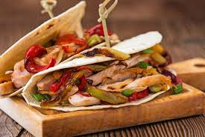

DIRECTIONS
- Preheat oven to 350 degrees.
- Mix chicken base and water together to form chicken stock. Place chicken stock in pan. Add frozen chicken, cover with saran wrap and foil and place in oven for approx. 20-25 minutes to warm.
- Place onions and peppers in a large skillet. Drizzle with some oil and sauté until crisp tender. Season with salt and pepper.
- Combine peppers and onions with chicken.
- Spoon filling in center of tortilla. Fold in half. Garnish with shredded cheese, salsa and/or sour cream.

Prep Time: 10 minutes | Cook Time: 20-25 minutes | Total Time: 30-35 minutes | Yield: 20 servings

