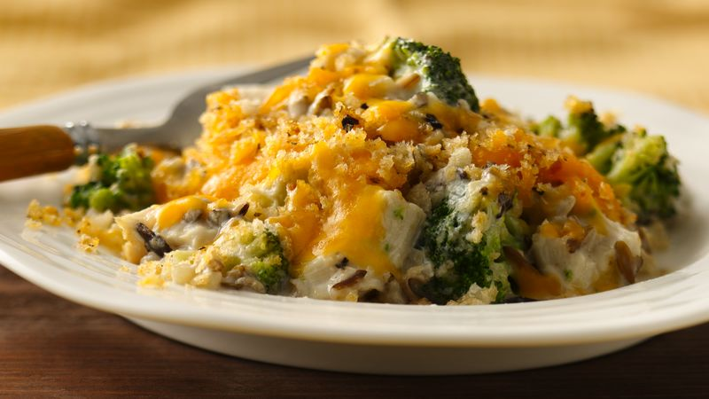
Chicken Divan
RECIPE
Note: This recipe can be used with turkey also.
INGREDIENTS
- 20 cups broccoli florets
- 5 pounds pulled or fajita chicken
- 6 cups cheddar cheese, shredded and divided
- 2 cups milk
- 1 1/3 cups sour cream
- 4 cans (10.5oz) cream of mushroom soup
- 2 teaspoons garlic powder
- 2 teaspoons onion powder
- 2 teaspoons dry mustard
- 2 teaspoons pepper
- 1 teaspoon seasoning salt
- Optional Ingredients:
Cream of chicken soup, curry powder, chicken broth, mozzarella

For Topping
- 12 tablespoons bread crumbs
- 4 tablespoons melted butter

DIRECTIONS
- Preheat oven to 350 degrees. Spray large baking pan with non-stick spray.
- Allow broccoli to thaw and drain away the excess liquid.
- In a medium bowl, combine 4 cups cheddar cheese, milk, condensed soup, sour cream and seasonings.
- Stir in broccoli and chicken and spread into prepared baking dish. Top with remaining cheese.
- In a small bowl, mix the butter and bread crumbs. Sprinkle the topping over the chicken mixture.
- Bake 20-25 minutes, or until the breadcrumbs are lightly browned and the mixture is bubbly and hot and reaches an internal temperature of 165 degrees.

Prep Time: 10 minutes | Cook Time: 20-25 minutes | Total Time: 30-35 minutes | Yield: 20-24 servings

