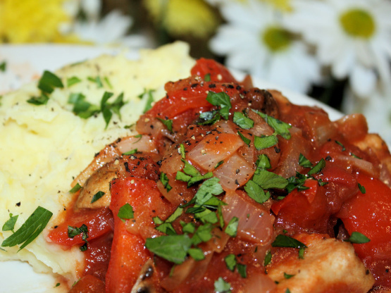
Chicken Cacciatore
RECIPE
INGREDIENTS
- 24 boneless skinless chicken breasts
- 8 tablespoons oil
- 8 tablespoons flour
- 1 tablespoon oregano
- 1 tablespoon garlic powder
- Salt and pepper
- 4 red or green peppers, cut into strips
- 3 cups onion, chopped
- 1 (#10) can diced or stewed tomatoes
- 1 1/3 cup low sodium chicken broth
- Optional Ingredients:
fresh chopped parsley, mushrooms

DIRECTIONS
- Heat oven to 350 degrees. Spray baking pan with non-stick spray.
- Heat oil in large roasting pan in oven 2 minutes.
- Combine flour, oregano, garlic powder, salt and pepper in large re-sealable plastic bag; add chicken pieces, tossing to coat well. Arrange chicken in pan; roast 20 minutes.
- Stir peppers and onions into pan with chicken; roast 15 minutes more, stirring once.
- Add tomatoes with their liquid, chicken broth (chicken base and water as directed on instructions) and salt, breaking up tomatoes with spoon.
- Roast 10-15 minutes longer until chicken is cooked through.
- Sprinkle with optional chopped parsley.

Prep Time: 10 minutes | Cook Time: 45 minutes | Total Time: 55 minutes | Yield: 24 servings

