Chicken and Noodles
RECIPE
INGREDIENTS
- 5 pounds pulled chicken
- 1 tablespoon dried parsley
- 1 ½ teaspoon pepper
- 1 teaspoon onion powder
- 1 teaspoon garlic powder
- 1 stick butter
- 10-14 cups low sodium chicken broth
- 72 ounces frozen egg noodles
- Optional Ingredients:
carrots, peas, fresh parsley, ground thyme, celery, onion, home-made egg noodles, chicken bouillon

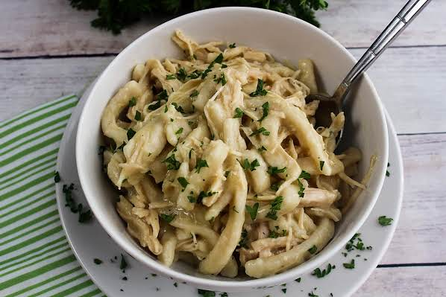

DIRECTIONS
- Place chicken, spices, butter and chicken broth (use chicken base and water as instructed) in a large pot. Bring to a boil, reduce heat, cover and simmer for 30 minutes. Stir occasionally.
- Add egg noodles and stir frequently so they do not stick to bottom of pan. Continue cooking for approx. 20-30 minutes, until noodles are tender.

Prep Time: 5 minutes | Cook Time: 50-60 minutes | Total Time: 55-65 minutes | Yield: 20-24 servings

