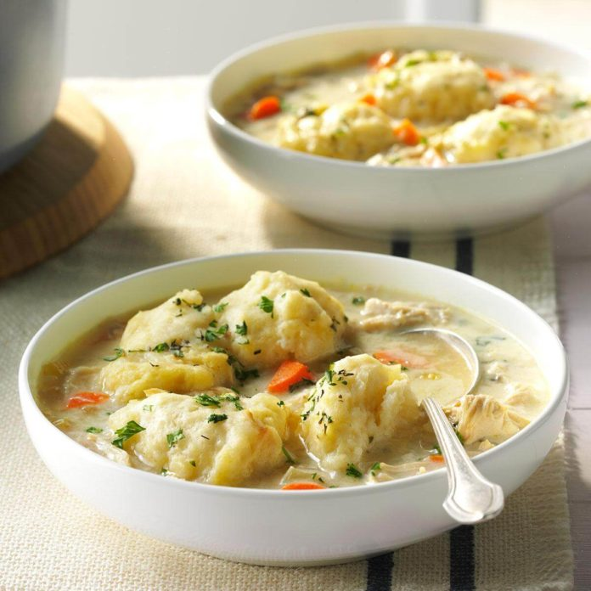
Chicken and Dumplings
RECIPE
INGREDIENTS
- 5 pounds pulled chicken
- 1 tablespoon dried parsley
- 1 ½ teaspoon pepper
- 1 teaspoon garlic powder
- 12-16 cups low sodium chicken broth
- 4 onions, diced
- 3-4 cups carrots, sliced
- 6 ribs celery, sliced
- Optional Ingredients:
peas, fresh parsley, ground thyme, chicken bouillon, biscuit mix instead of dumplings below

For Dumplings
- 4 cups flour
- 6 teaspoons baking powder
- 2 ¼ teaspoons salt
- 2 cups milk
- 3 tablespoon butter, melted

DIRECTIONS
- Place chicken, spices, chicken broth (use chicken base and water as instructed), onions, carrots and celery in a large pot. Bring to a boil, reduce heat, cover and simmer for 30 minutes to ensure chicken is tender and vegetables are cooked. Stir occasionally.
- Meanwhile, in a bowl, whisk flour, baking powder and salt. In another bowl, whisk milk and melted butter until blended. Add to flour mixture; stir just until moistened (do not overmix). Drop by rounded tablespoons onto a parchment paper-lined baking sheet; set aside until ready to add to stockpot with soup.
- Drop dumplings on top of simmering soup, a few at a time. Cover and simmer for 15 to 18 minutes.
- Serve immediately.

Prep Time: 25 minutes | Cook Time: 50 minutes | Total Time: 75 minutes | Yield: 24 servings

