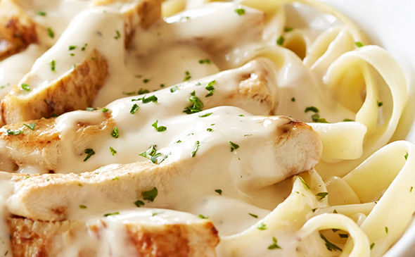
Chicken Alfredo
RECIPE
Note: This recipe may also be used with turkey.
Note: No need for an additional carbohydrate since the main dish contains pasta

INGREDIENTS
- 4 pounds fettuccini
- 1 (5#) bag of chicken fajita breast strips
- 2 cups chicken stock
- Optional Ingredients:
fresh parsley, bacon

For Sauce
- 2 ½ cup butter
- 15 cloves garlic, minced
- Salt and pepper
- 7 ½ tablespoons flour
- 10 cups milk
- 3 ¾ cup grated Parmesan cheese
- Optional Ingredients:
nutmeg, mushrooms, Alfredo sauce mix, heavy cream

DIRECTIONS
- Preheat oven to 350 degrees.
- Place chicken stock in pan. Add frozen chicken, cover with parchment and foil and place in oven for approx. 20 minutes to warm.
- For sauce: Melt butter in pot over medium heat and add garlic. Cook for 30 seconds, then reduce heat to medium-low. Season with salt and pepper. Whisk in flour, stirring until smooth. Slowly whisk in cream. Cook until sauce is slightly thickened and whisk in parmesan. Stir until smooth. Remove from heat and cover until ready to serve. If sauce is too thick, thin down with chicken stock leftover from warming the chicken.
- Place pasta on plate, top with chicken then sauce. Garnish with parmesan and parsley if desired.

Prep Time: 15 minutes | Cook Time: 30 minutes | Total Time: 45 minutes | Yield: 20-24 servings

