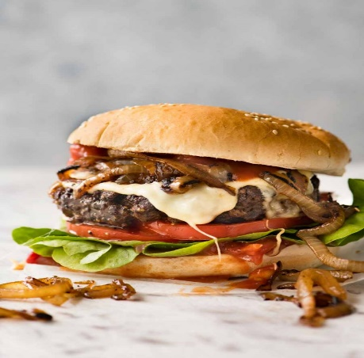
Cheeseburger
RECIPE
w/Grilled Onions

INGREDIENTS
- 5 pounds ground beef
- Salt and pepper
- 1/3 cup oil
- 6-8 onions sliced into rings
- 20 slices Swiss cheese
- Non-stick cooking spray
- 20 hamburger buns
- 1 head lettuce
- 4-5 tomatoes
- Optional Ingredients:
American cheese, mushrooms, Worcestershire sauce, butter, sliced pickles, bacon

DIRECTIONS
- Separate beef into 20 equal portions. Form into patties.
- Season with salt and pepper. Press with your finger to make a dent in the middle of the burger (stops burger from become dome shape and shrinking when cooking).
- Heat oil in skillet over medium-high heat. Add onion and cook until wilted and caramelized. Season with salt and pepper, then remove and set aside.
- Fry or grill patties until internal temperature reaches 165 degrees. (Tip: When the burger has cooked halfway up the sides and has released itself from the grill or pan, it's time to flip. Only flip once.)
- Top with cheese. Cover with lid and cook for further 1 minute until cheese is melted.
- Meanwhile, spray non-stick oil on buns and toast the cut side of the buns lightly.
- To serve, place lettuce, tomato and patty on bun. Placed onions on melted cheese and top with lid of bun. Serve immediately.

Prep Time: 15 minutes | Cook Time: 20 minutes | Total Time: 30 minutes | Yield: 20 servings

