Cashew Chicken
RECIPE
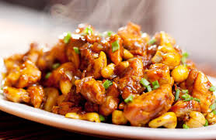
INGREDIENTS
- 5 pounds frozen breaded fully cooked chicken breast chunks
- Optional Ingredients:
green onions, cashews

For Sauce
- ½ can (64oz) oyster sauce no MSG
- ½ bag roast beef gravy
- 1 gallon water
- 1 ¼ tablespoon garlic powder
- 1 ¼ tablespoon onion powder
- 1 tablespoon soy sauce
- 1 tablespoon ground ginger
- 1 tablespoon celery seed
- ½ cup cornstarch
- Optional Sauce:
Cashew sauce mix

DIRECTIONS
- Preheat oven to 375degrees. Place chicken chunks on tray and bake as directed on package.
- For sauce: Place ¾ gallon water in large pot. Bring to boil. Add gravy mix and oyster sauce. Mix cornstarch and remaining water in a bowl and add to gravy mixture. Add seasonings and stir. Taste sauce and add more of the seasonings as desired. Do not add chicken to sauce. Pour sauce over chicken when served.

Prep Time: 10 minutes | Cook Time: 30 minutes | Total Time: 40 minutes | Yield: 20 servings

