Carved Turkey Breast
RECIPE
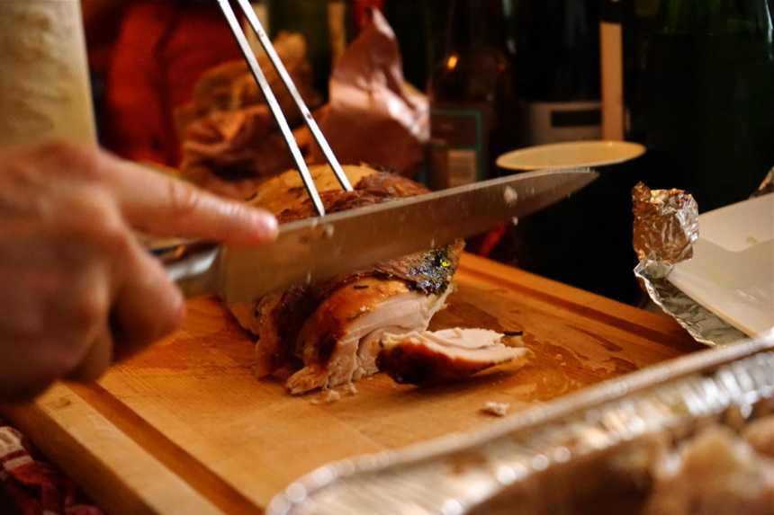
INGREDIENTS
- 6 pound netted turkey roast
- Vegetable oil or spray
- Onion powder
- Salt
- Pepper
- Garlic Powder
- Optional ingredients:
rosemary, thyme

DIRECTIONS
- Preheat oven to 325 degrees.
- Remove whole breast from bag. Drain juices and pat dry with clean paper towels. Adjust netting to make it easier to remove when you're ready to carve and serve Place breast, skin side up, in a 2-inch deep roasting pan with rack. Do not add water to pan.
- Brush or spray skin lightly with vegetable or cooking oil for best appearance.
- Roast uncovered until meat thermometer in thickest part of breast reaches 170° F. (2-2 ½ hours)
- Before you remove the netting and carve, let your turkey breast stand for 15 minutes to allow the juices to set (you may pre portion and serve from cafeteria pan instead of carving).

Prep Time: 10 minutes | Cook Time: 120 minutes | Total Time: 130 minutes | Yield: 24 servings

