Carved Smoked Sausage
RECIPE
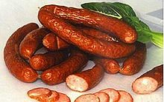
INGREDIENTS
- 11 pound Endless Smoked Sausage
- 2 cups Water

DIRECTIONS
- Pre heat oven to 375º
- Add water to cover bottom of sheet pan (about a ¼ inch).
- Place sausage on cooking rack and cover with foil.
- Heat 15-20 minutes until sausage reaches an internal temperature of 165 degrees.
- Place on decorated carving board and under a heat lamp and carve for your guests. If not carving, then pre-portion and place in shallow 2” full cafeteria pan and place on steam table.

Prep Time: 5 minutes | Cook Time: 15-20 minutes | Total Time: 20-25 minutes | Yield: 44 servings

