Carved Roast Beef
RECIPE
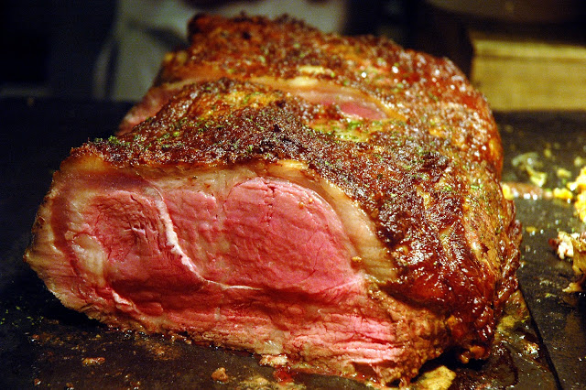
INGREDIENTS
- 18 lb. Beef, Boneless, inside round
- 2 Tbsp. salt
- 1Tbsp. ground Pepper
- Garlic powder
- Onion Powder
- 2 quarts water

- Season meat with salt and pepper and place in roasting pan
- Place roast in oven at 450 degrees for about 30 minutes (until brown)
- When meat is brown, add 2 quarts’ water and reduce heat to 300 degrees
- Cover and cook slowly until tender (about 3 hours). Add water as needed.
- When meat is done (140 degrees for rare, 145 for medium rare, and never cook above 145 degrees). Let your roast rest for 30 minutes and the temperature of the roast will rise 10 to 15 degrees
- Save your drippings for gravy!
- Carve this roast on a decorated carving board for your guests (3 ounce servings) and they will love you for your efforts.

Prep Time: 15 minutes | Cook Time: 210 minutes | Total Time: 225 minutes | Yield: 50 servings

