Carved Honey Ham
RECIPE
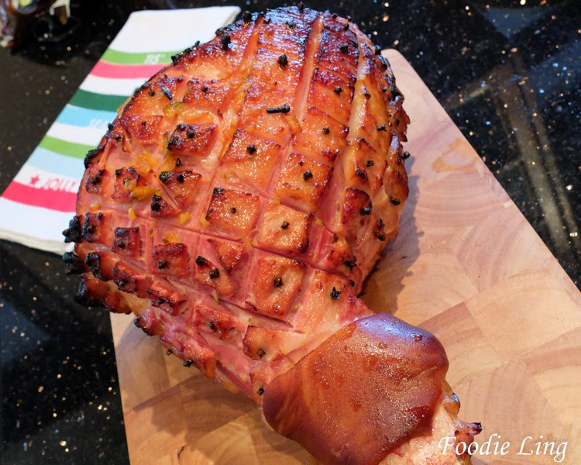
INGREDIENTS
- 1 Farmland Pit Carving Ham
- 2 cups water
- 1 cup honey
- ½ cup brown sugar
- 1 tsp ground cloves
- ½ tsp ground mustard
- Optional Ingredients:
whole cloves

DIRECTIONS
- Pre heat oven to 325 degrees.
- If under a time restraint, cut the ham in half lengthwise.
- Score the ham making diamond cuts ½ inch deep.
- Place the whole roast or the halves in a well-greased foil lined baking pan.
- Add water to pan.
- In a bowl combine the honey, brown sugar, ground cloves and mustard; pour over ham.
- Bake, uncovered till thermometer reads 140º, basting with pan juices often. Add additional water to pan if necessary.

Prep Time: 20 minutes | Cook Time: 35 minutes | Total Time: 65 minutes | Yield: 50 servings

