Classic Carrot Salad
RECIPE

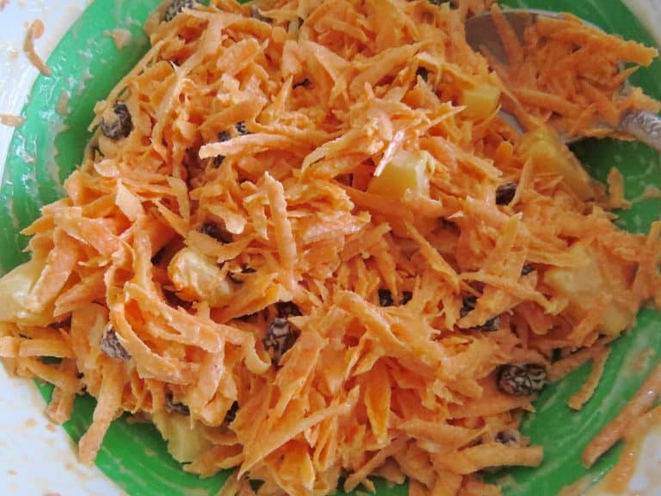
INGREDIENTS
- 4 pounds carrots
- 2 cups raisins
- 4 cups hot water
- 2 (20 ounce) cans of pineapple tidbits, drained
- 2 cups mayonnaise
- 4 tablespoons sugar

DIRECTIONS
- Place raisins in hot water so they plump back up (approx. 10-15 minutes). Once plumped, drain off water.
- Drain pineapple tidbits of excess juice.
- Peel carrots and then grate them.
- In a large bowl, toss grated carrots with mayo and sugar.
- Then add in raisins and pineapple and stir until combined.
- Cover and put in the fridge to chill thoroughly.

Prep Time: 30 minutes | Cook Time: 15 minutes | Total Time: 45 minutes | Yield: 24 servings

