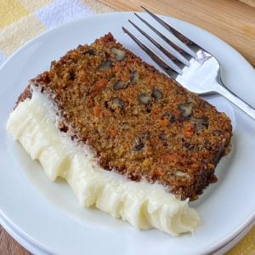 Carrot Cake Loaf

Ingredients:
1 bag spice cake mix, (make mix according to directions on bag)
8 cup grated carrots
Frosting:
1 bag powder sugar
1 ½ cup softened butter
25 ounces softened cream cheese (half a 5 lb. brick of cream cheese)
2 tsp vanilla

Additions Optional:
6 cups raisins, 5-6 cups chopped walnuts
Instructions for Cake:
Preheat oven to 350 degrees
Mix cake mix according to package and fold in carrots, nuts and raisins. Pour into greased loaf pans. Bake about 25 – 30 minutes until toothpick inserted in the center comes out clean.
Instructions for Frosting:
Beat butter and cream cheese until smooth add powder sugar and vanilla until creamy. Spread frosting evenly over cooled loaves.

