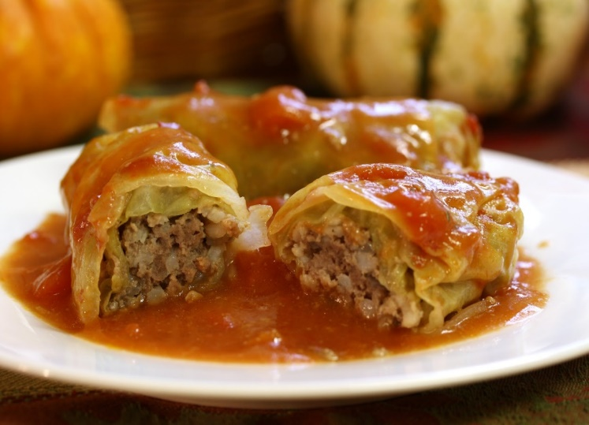
Cabbage Rolls
RECIPE

INGREDIENTS
- 2 cups water
- 1 cup uncooked white or brown rice
- 24 cabbage leaves (approx. 2 heads)
- 1 tablespoon vinegar
- 3 pounds ground beef
- 1 cup onion, chopped
- 3 eggs, slightly beaten
- Salt and pepper
- 3 cans (10.75 ounce) condensed tomato soup
- 2-3 cans (14.5 ounce) of diced tomatoes
- Optional Ingredients:
Ground pork, parsley, tomato sauce, pasta sauce, tomato paste, sugar, dill, garlic

DIRECTIONS
- In a medium saucepan, bring water to a boil. Add rice and stir. Reduce heat, cover and simmer for 20 minutes so rice is slightly underdone. Set aside.
- To remove leaves from head of cabbage, cut approx. 1/4" off the bottom of the head and place the whole head of cabbage in boiling water and vinegar. Boil about 2 minutes. Peel off the softened leaves. Place remaining head back in the boiling water and repeat until all of the leaves are removed. Remove any tough stems from cooked leaves.
- Preheat oven to 350 degrees.
- In a medium mixing bowl, combine the ground beef, cooked rice, onion, egg, salt and pepper, along with 6 tablespoons of tomato soup. Mix thoroughly.
- Place about ¼ cup beef mixture on cabbage leaf and roll. Repeat for all cabbage leaves.
- Place the cabbage rolls seam side down in large baking pan and pour the remaining tomato soup and diced tomatoes over the top. Cover and bake about approx. 75-90 minutes until internal temperature reaches 165 degrees, basting with the liquid occasionally.

Prep Time: 30 minutes | Cook Time: 90 minutes | Total Time: 120 minutes | Yield: 24 servings

