Cabbage (Garlic and Fried w/Apples)
RECIPE
DIRECTIONS
- In a large skillet, heat butter and oil over medium heat; add cabbage, garlic and brown sugar.
- Sauté cabbage about 5 minutes. Reduce heat to medium-low and stir in vinegar.
- Cook, stirring often, for approximately 20 minutes; taste and if cabbage is too crunchy, cook for a few more minutes.
- Add salt and pepper to taste and serve.

INGREDIENTS
- 3 heads of white cabbage, thinly sliced
- 6 tablespoons of butter
- 3 tablespoons oil
- 3 tablespoons packed brown sugar
- 12 cloves garlic, minced
- 3 tablespoons red wine vinegar
- Salt and pepper

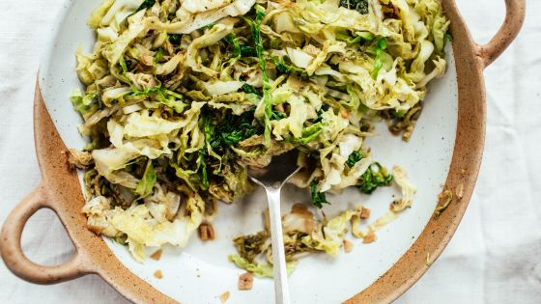

INGREDIENTS
- 12 tablespoons butter
- 6 apples, coarsely grated3
- head of green cabbage, thinly sliced (about 3 – 4 cups)
- 6 small Vidalia onion, thinly sliced
- 3 teaspoons salt
- ¼ teaspoon ground nutmeg
- 12 tablespoons cider vinegar
- 2 tablespoons sugar
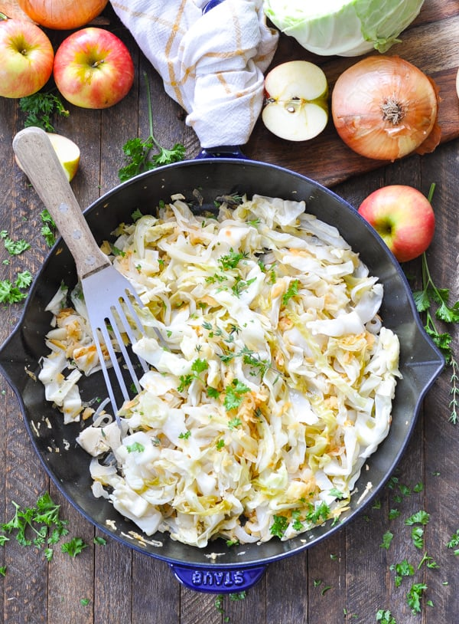
DIRECTIONS
- Melt butter in a large skillet.
- Add apples, cabbage, onion, salt, nutmeg, vinegar, and sugar; sauté over medium-high heat until tender (about 12-15 minutes).
- Season with salt and pepper, to taste.

Note: might want to cook in batches and place in warmer until ready to serve.

Prep Time: 20 minutes | Cook Time: 0 minutes | Total Time: 20 minutes | Yield: 24 servings

