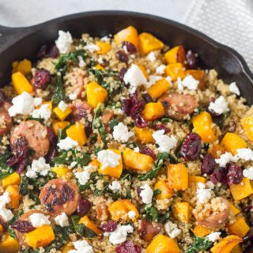 Butternut Squash, Kielbasa Sausage, and Brussel Sprouts Quinoa Skillet

Servings: 25 large servings
Ingredients

7 cup uncooked quinoa

7 medium butternut squash peeled and diced into bite-sized pieces (or 2 bags of already prepared butternut squash)

1 cup 5 tablespoons oil

3 1/2 yellow onion diced

5 lbs Kielbasa sausage, cut into bite-sized pieces

28 cups chopped Brussel Sprouts (fresh or frozen make sure to thaw them)

7 teaspoon minced garlic

Dressing

7 tablespoons oil

7 tablespoon maple syrup

7 teaspoon apple cider vinegar

3 1/2 cup dried craisins

28 ounces crumbled feta cheese

Instructions
Preheat oven to 425 degrees F.
- Place butternut squash on baking sheet (I lined mine with aluminum foil for easier clean up) and drizzle with ¼ cup of oil. Toss to combine. Season with salt and pepper.
- Bake in preheated oven for about 25 minutes, until squash is soft.

- Meanwhile, cook quinoa to directions on package
- While quinoa and squash are cooking, add remaining olive oil to a skillet over medium heat. Sauté onions and kielbasa sausage cook until onion begins to soften, about 5-7 minutes.
- Add the Brussel sprouts, garlic and sage and cook.
- Once squash and quinoa have cooked, add them both to the skillet with the sausage and Brussel sprouts stir to combine.
- Mix together Dressing ingredients (olive oil, maple syrup, and apple cider vinegar) drizzle over quinoa mixture, stirring to combine. Season with additional salt and pepper, to preference.
- Top with cherries, goat cheese.
- Enjoy!

