Brussel Sprouts (Sweet and Parmesan)
RECIPE
DIRECTIONS
- Preheat oven to 375 degrees. Spray a pan with non-stick spray.
- Steam Brussels sprouts over boiling water until tender, about 10-15 minutes. Transfer to pan.
- Add butter, brown sugar and honey.
- Cover and bake for 25-35 minutes until sweet and tender.
INGREDIENTS
- 20 cups Brussel sprouts
- 1 stick butter, melted
- 1 ½ cups brown sugar
- ¼ cup honey
- Salt and pepper
- Optional Ingredients:
Bacon, chicken broth, onion, maple syrup

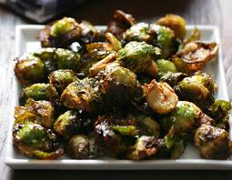

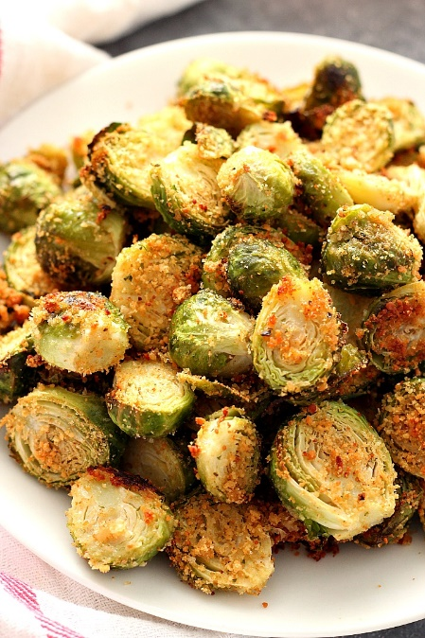
DIRECTIONS
- Preheat oven to 375 degrees. Spray a pan with non-stick spray.
- Steam Brussels sprouts over boiling water until tender, about 10-15 minutes. Transfer to pan.
- Toss Brussel sprouts with oil, sprinkle with garlic powder, salt, pepper, top with parmesan cheese and breadcrumbs.
- Bake for 20-30 minutes until tender.
INGREDIENTS
- 20 cups brussel sprouts
- 6-8 tablespoons olive oil
- 1 ½ -2 cups parmesan cheese
- 1 tablespoon garlic powder
- ¾ cup breadcrumbs
- Salt and pepper

Prep Time: 20 minutes | Cook Time: 0 minutes | Total Time: 20 minutes | Yield: 20 servings

