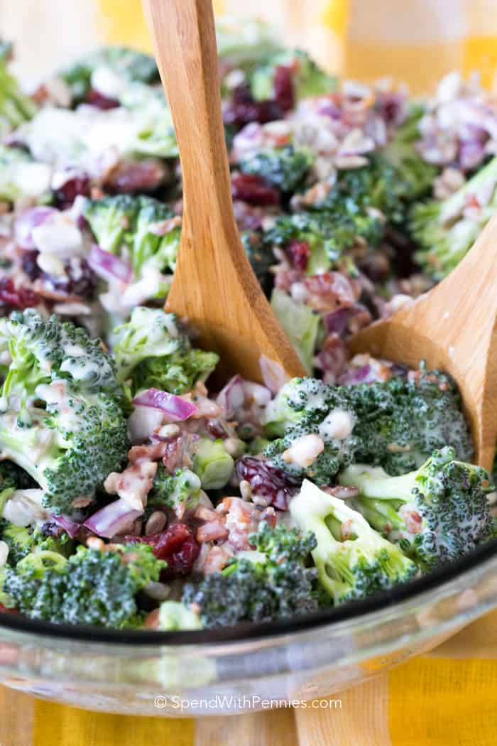
Broccoli Salad
RECIPE

INGREDIENTS
- 1 pound bacon
- Salt
- 10 cups small broccoli florets
- 2 cups mayonnaise
- 2 tablespoons cider vinegar
- 2/3 cup chopped red onion
- ½ cup sugar
- 1 ½ cup raisins
- 1 cup sunflower seeds

DIRECTIONS
- Cut the bacon into small pieces and cook over medium heat just until crisp; drain on paper towels.
- Bring a large saucepan of salted water to a boil. Add the broccoli and blanch until bright green and slightly softened, about 3 minutes. Drain well, run under cold water to stop the cooking, and drain again.
- In a mixing bowl, combine the mayonnaise, vinegar, onion, sugar and raisins. Add the broccoli and toss the coat with the dressing. Refrigerate for 1 hour.
- Just before servings, fold in the sunflower kernels and the bacon pieces. Serve immediately.

Prep Time: 15 minutes | Cook Time: 15 minutes | Total Time: 90 minutes | Yield: 20 servings

