Broccoli Beef
RECIPE
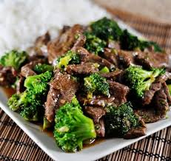
INGREDIENTS
- 2 ½ cups oyster sauce
- 1 ¼ cup cornstarch
- ¼ cup low sodium soy sauce
- ¼ cup granulated sugar
- 5 pounds thinly sliced beef
- ¾ cup canola oil
- 8 cloves garlic, minced
- 2 tablespoons ginger
- 5 pounds broccoli
- Optional Ingredients:
sliced onions, brown sugar, beef broth, sesame oil, honey, rice wine vinegar, red pepper flakes, green onions

DIRECTIONS
- Preheat oven to 350 degrees. Spray a 2” pan with non-stick spray.
- Add everything except broccoli to a large bowl and mix.
- Place mixture in prepared pan and cover with foil.
- Bake 30 minutes until beef is tender.
- Steam broccoli and stir into booked beef mixture.

Prep Time: 20 minutes | Cook Time: 30 minutes | Total Time: 50 minutes | Yield: 20 servings

