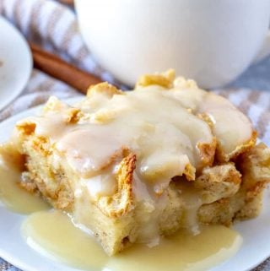 Bread Pudding
- 1 pound loaf day old Bread (French, Italian, or Challah), torn into small pieces
- 2 cup milk
- 1-1/2 cups Granulated Sugar
- 3 tablespoon Melted Butter
- 4 Eggs
- 2 teaspoons Vanilla

Instructions
- Preheat oven to 350 degrees F.
- Spray foil pans with cooking spray and place torn pieces of bread in the dish.
- In a large bowl, whisk together the milk, sugar, melted butter, eggs, vanilla.
- Slowly pour the batter over the bread pieces in the baking dish. Be sure to cover all the bread pieces (if you feel it’s dry add about ¼ milk to the top while in pan)
- Bake in a preheated oven at 350 for about 1 hour.
- While the bread pudding is baking, make a powder sugar glaze (thick) for the top.
- Pour over bread pudding to serve.

Additions to try:
1 15-ounce can Pumpkin Puree 1 tablespoon Pumpkin Pie Spice
Chocolate Chips (or any flavor you like), Chopped Nuts, Get Creative with this versatile recipe

