Braised Pork Chops
RECIPE
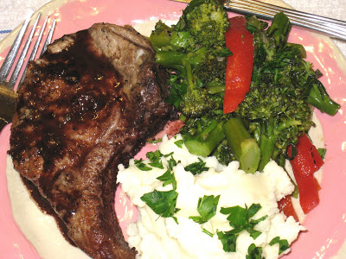
INGREDIENTS
- 24 pork chops
- 1 cup oil
- 2 tablespoons Dijon mustard
- 1 tablespoon salt
- ½ cup brown sugar
- ½ cup red-wine vinegar
- ½ cup Worcestershire or soy sauce
- 1 1/3 cup water

DIRECTIONS
- Heat oil in heavy skillet over medium heat. Brown pork chops on both sides, about 2-3 minutes per side
- Meanwhile, in medium mixing bowl, add mustard, salt, sugar, vinegar, Worcestershire and water. Mix well.
- Divide pork chops evenly between two 2” pans.
- Pour mixture over pork chops
- Cover pans with foil and bake in oven for 1 ½ hours
- When tender remove chops from pan and cook pan juices until thickened (adding a little corn starch may speed up the thickening process). Internal temperature should be 145 degrees.
- Pour sauce over pork chops and serve immediately.

Prep Time: 20 minutes | Cook Time: 90 minutes | Total Time: 110 minutes | Yield: 6 servings

