Boiled Corned Beef
RECIPE
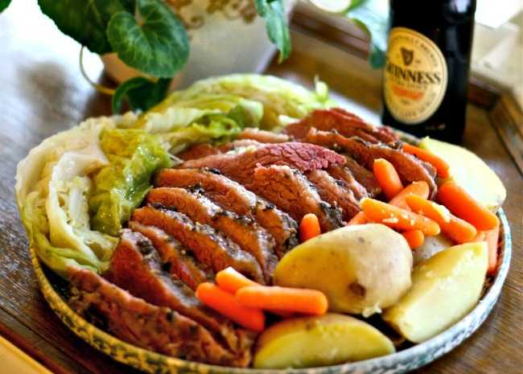
INGREDIENTS
- 6 pound corned beef brisket
- 2 cups water

- Place the brined corned beef in a large pot or Dutch oven along with the liquid and spices that accompanied it in the package.
- Pour in enough water to cover the beef, then bring the water to a boil on the stovetop.
- Reduce the heat to a simmer, and cover the pot. A three-pound corned beef could take three hours or more to become perfectly tender. Check the meat occasionally, adding more water if necessary.
- The beef is ready when it pulls apart easily. For a one-pot feast, you can add cabbage and chunks of potatoes and carrots to the pot during the last half hour of cooking.

Prep Time: 10 minutes | Cook Time: 360 minutes | Total Time: 370 minutes | Yield: 20-24 servings

