Blackened Fish
RECIPE
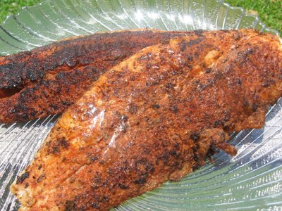
INGREDIENTS
- 24 fish fillets, 4 oz each
- 1/3 cup oil
- 1 ½ sticks of butter
- 4 ½ teaspoons garlic powder
- 1 tablespoon salt
- 1 tablespoon pepper
- 3 tablespoons paprika
- 2 tablespoons oregano
- 1 tablespoon cumin
- 3 tablespoons brown sugar
- Optional Ingredients
thyme, onion powder, cayenne, lemon slices

DIRECTIONS
- Combine seasonings and brown sugar in a small bowl.
- Rub seasonings over fish.
- Heat small amount of oil and 2-4 tablespoons of butter in a skillet over medium-medium high heat.
- Add fish fillets to fill the skillet not overcrowding and cook 3 minutes on each side or just until done. Keep in warmer until all fish is cooked and ready to serve.
- Wipe out pan and add oil and butter to brown additional fish fillets. Continue until you are done cooking all fillets.

Prep Time: 20 minutes | Cook Time: 20 minutes | Total Time: 40 minutes | Yield: 24 servings

