Beet Salad (Pickled and Madarin Orange)
RECIPE

INGREDIENTS
- #10 can of sliced beets
- 1 ½ cup sugar
- 2 tablespoons yellow mustard
- 1 ½ cup white or red wine vinegar
- 1 ½ cup red onion, diced
DIRECTIONS
- Drain beets, reserving 1 ½ cup liquid. Add onions and toss.
- In a saucepan over medium heat, cook the sugar, mustard and reserved liquid until dissolved. Add vinegar and bring to boil; remove from heat and cool.
- Pour over the beet slices and onions, toss and refrigerate for 4 to 6 hours.

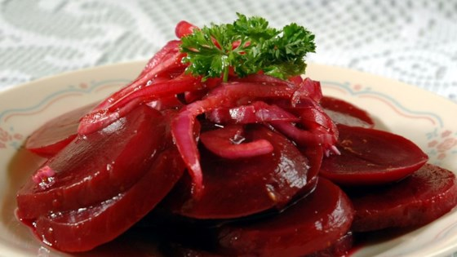

INGREDIENTS
- #10 can mandarin oranges, drained
- 1 cup of drained mandarin orange liquid
- 1 cup cider vinegar
- ½ cup olive oil
- ¼ cup Dijon mustard
- #10 can sliced beets,
- quartered
- Salt and pepper
DIRECTIONS
- In a large bowl, whisk together mandarin orange liquid, vinegar, oil, and mustard.
- Add beets and drained oranges to the large bowl and toss to coat.
- Season, to taste, with salt and ground black pepper.
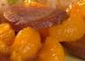

Prep Time: 10 minutes | Cook Time: 10 minutes | Total Time: 20 minutes | Yield: 15-20 servings

