Beef Tips
RECIPE
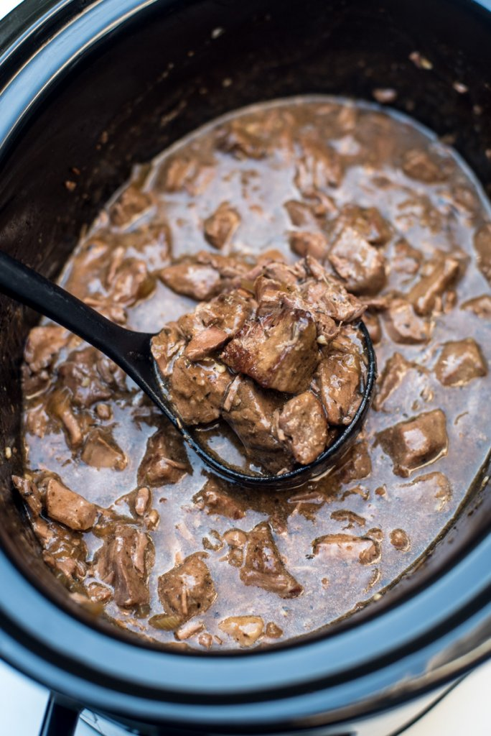
INGREDIENTS
- 8 pounds beef stew meat
- Salt and pepper
- 12 tablespoons vegetable oil, divided
- 2 onions, chopped
- 12 cloves garlic, minced
- 16 cups low sodium beef broth
- 8 tablespoons Worcestershire sauce
- 4 tablespoon soy sauce
- 4 bay leaves
- Optional Ingredients:
sliced mushrooms, seasoned salt. Italian seasoning, thyme

DIRECTIONS
- Add 4 tablespoons oil to large pot and heat on medium-high. Add onions and cook until tender and brown. Add garlic and cook 1 minute. Remove onions and garlic to a bowl and set aside.
- Deglaze pan if needed with 1 cup beef broth. Pour liquid in bowl with onions mixture.
- Season meat. Add remaining oil to pot and once heated add meat so pieces are browned on all sides.
- Add remaining beef broth, onion mixture, Worcestershire sauce, soy sauce and bay leaves. Bring to a simmer and cook for 60-90 minutes or until the beef is tender.
- Drain liquid to make gravy. Serve over potatoes, rice or pasta.

Prep Time: 15 minutes | Cook Time: 60-90 minutes | Total Time: 75-105 minutes | Yield: 24 servings

