Best Ever Beef Stew
RECIPE
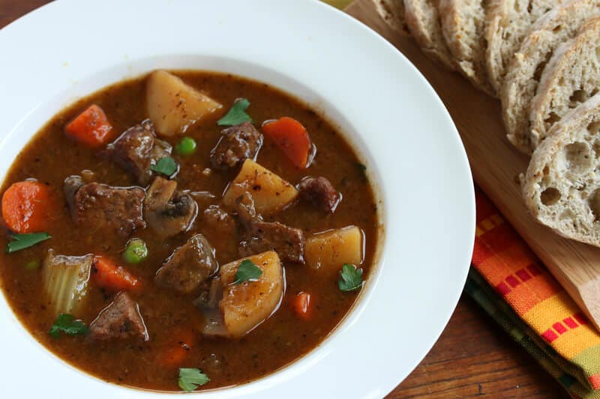
DIRECTIONS
- In a large Ziplock bag, add flour and seasoned salt. Seal bag and shake to combine ingredients.
- Add stew meat to flour a handful at a time and coat with flour mixture.
- In large pot, over medium high heat, pour 1/3 of your vegetable oil. You want the oil nice and hot so that the meat will brown quickly.
- Once the oil is hot, add the floured beef chunks. Repeat remaining beef in batches till all beef is browned. We are not cooking the beef all the way. Just browning it will help give the beef a great color and flavor. Set all be aside and season with pepper.
- If necessary, add a tad bit more oil to bottom of pan and turn heat down to medium, then add onion and celery. Cook until translucent. Scrape bottom of pan to loosen any brown bits (lots of flavor in the bottom of the pot).
- Mix water and beef stock and stir till dissolved. Add beef broth, Worcestershire sauce, garlic and browned beef to pot.
- Toss in carrots and potatoes on medium heat for about 30 minutes, stir, then turn to low and allow to simmer till meat is tender, about three hours.
- Add peas 10 minutes before you are ready to serve.

INGREDIENTS
- 5 Pounds beef stew meat
- 1 ½ cups all-purpose flour
- 2 ½ tablespoon seasoned salt
- 1 tablespoon black pepper
- ¾ cup vegetable oil
- 2 large yellow onions, diced
- 5 stalks celery, diced
- 7 ½ cups water
- 3 tablespoons of beef base paste
- 2 tablespoons Worcestershire sauce
- 1 tablespoon minced garlic
- 10 potatoes peeled and diced into chunks
- 2 cups carrots, sliced
- 2 cups frozen peas

Prep Time: 80 minutes | Cook Time: 75 minutes | Total Time: 155 minutes | Yield: 24 servings

