Beef Pot Pie
RECIPE
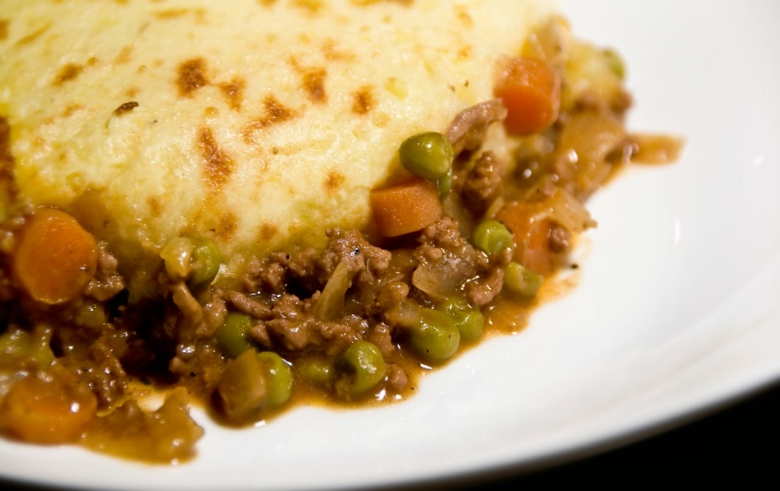
INGREDIENTS
- 5 pounds ground beef
- 1 tablespoon garlic, chopped
- 1 small onion, diced
- ½ large can (25oz) condensed cream of mushroom soup
- 2 cups peas and carrots
- 6 cups cheddar cheese, shredded
- Salt and pepper

For Cornbread
- ¼ bag of cornbread mix
- 1 ¾ cup water
- Optional Ingredients:
Pie crust, mashed potatoes, biscuits, mashed sweet potatoes, corn, green beans

Note: No need for an additional carbohydrate since the main dish contains cornbread, peas, and carrots

DIRECTIONS
- Preheat oven to 375 degrees F. Spray baking pan with non-stick spray.
- Preheat skillet on medium-high heat. In a large skillet, ground beef, garlic and onion, stirring so that the ground beef crumbles and becomes fully cooked.
- Place cooked beef mixture in a large bowl, add soup, peas and carrots. Place mixture in prepared pan.
- Layer cheese evenly over beef mixture.
- In a bowl, combine cornbread and water. Mix until smooth. Pour a thin layer (between ¼ and ½ inch thick) over cheese.
- Bake approx. 35-45 minutes or until cornbread is fully cooked and internal temperature reaches 165 degrees

Prep Time: 20 minutes | Cook Time: 40 minutes | Total Time: 60 minutes | Yield: 20 servings

