Beef Enchiladas
RECIPE
INGREDIENTS
- 5 pounds ground beef (could also use cooked pulled chicken)
- Salt and Pepper
- 10-12 cups mild enchilada sauce
- 2 ½ onions, chopped
- 50 flour tortillas (6-inch)
- 7 ½ cups shredded cheddar cheese
- Bunch green onions, chopped
- Optional Ingredients:
Green chiles, spinach, black beans, chicken stock may be used to thin enchilada sauce if needed

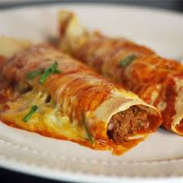

DIRECTIONS
- Heat oven to 375°F. Spray 2” pan with non-stick cooking spray.
- In a skillet, cook beef over medium-high heat 5 to 7 minutes, stirring occasionally, until thoroughly cooked; drain.
- Stir in 2 ½ cups of enchilada sauce.
- Spread 2 ½ cups of the enchilada sauce evenly in pan. Spread small amount of beef mixture in center of each tortilla, top with 1 tablespoon cheese. Wrap tortillas tightly around filling, placing seam side down in baking dish. Top with remaining enchilada sauce. Sprinkle with remaining cheese.
- Bake 20 to 30 minutes or until internal temperature reaches 165 degrees. Should be hot and bubbly. Let stand 5 minutes before serving. Serving size is 2 enchiladas.

Prep Time: 20 minutes | Cook Time: 50 minutes | Total Time: 70 minutes | Yield: 25 servings

