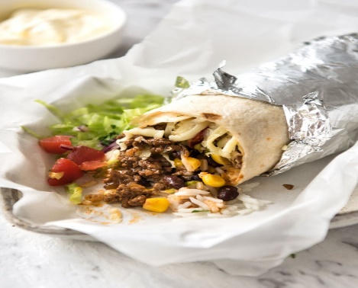
Beef Burritos
RECIPE
INGREDIENTS
- 2 ½ tablespoon oil
- 2 ½ cups onion, finely diced
- 5 pounds ground beef
- 2 ½ teaspoons garlic powder
- Salt and pepper
- 5 teaspoons onion powder
- 5 teaspoons dried oregano
- 3 tablespoons cumin
- 3 tablespoons paprika
- 3 tablespoon + 1 teaspoon tomato paste
- 1 cup water
- 20 large soft flour burrito shells
- 5 cups cooked rice
- 3 ½ cups frozen corn, thawed
- 3 ½ cups black beans
- 5-6 tomatoes, deseeded and diced
- 1 head lettuce, shredded
- 6 cups shredded cheese
- Optional Ingredients:
minced garlic, salsa, taco seasoning, green onion

DIRECTIONS
- Heat oil in a skillet. Add onion, cook for 2 minutes until onion is lightly browned. Add beef and garlic powder to pan, stirring to break up beef, until it browns.
- Add seasonings and cook for 1 minute. Then add tomato paste and water, cook for 3 minutes until the water is mostly evaporated but the beef is still juicy, not dried out. Set aside to cool for 10 minutes – piping hot filling will steam the burrito, making the tortilla soggy.
- Place a flour shell on work surface. Place 1/4 to 1/3 cup of in shell. Top with 1/4 to 1/3 cup beef, then some corn, black beans, tomato, lettuce and cheese.
- Fold up the bottom to cover the filling then fold the edges in. Roll up tightly, then wrap in foil.
- To warm, bake at 350 degrees for 20 minutes in the foil – this will warm them all the way through and crisp up the tortilla slightly. If they are straight from the fridge, they will take around 30 minutes to warm through.
- Burritos are best served with a dollop of sour cream and/or salsa

Prep Time: 30 minutes | Cook Time: 20 minutes | Total Time: 50 minutes | Yield: 20-26 servings

