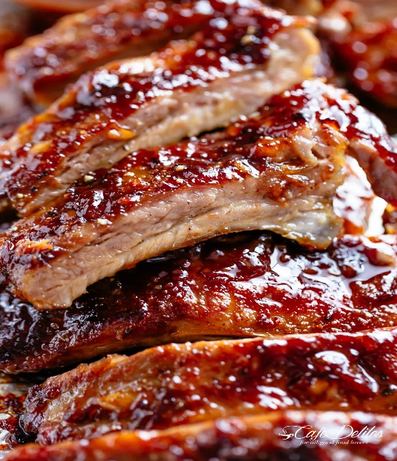
BBQ Ribs
RECIPE
INGREDIENTS
- 16 pounds pork ribs
- 8 teaspoons garlic powder
- 4 teaspoon onion powder
- 8 teaspoons paprika
- 8 teaspoons salt
- 4 teaspoon cracked black pepper
- 2 teaspoons cumin
- 4 teaspoon chili powder
- 8 tablespoons olive oil

DIRECTIONS
- Preheat oven to 350°F (180°C).
- Peel off tough membrane that covers the underside/bony side of the ribs. Place on a baking sheet sprayed with non-stick spray or one lined with parchment paper.
- Combine together garlic powder, onion powder, paprika, salt, pepper, cumin and chili powder. Sprinkle seasoning over ribs and drizzle with oil. Rub the seasoning all over the ribs on both sides. Cover tray with foil and bake for 2 hours.
- Remove ribs from the oven, remove foil and spread the tops of the ribs with the barbecue sauce.
- Increase oven temperature to 460°F. Return ribs to the oven, uncovered, and bake for a further 10 minutes.
- Rest for 10 minutes to allow the juices to recirculate back into the meat before slicing

Prep Time: 15 minutes | Cook Time: 135 minutes | Total Time: 150 minutes | Yield: 24 servings

