BBQ Chicken
RECIPE
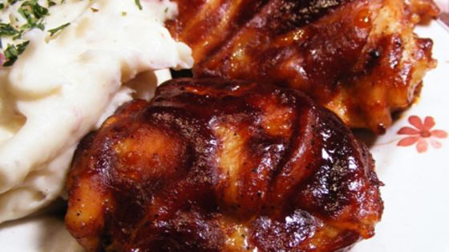
INGREDIENTS
- 24 chicken pieces
- seasoning salt
- garlic powder
- ground black pepper
- 6-8 cups barbecue sauce
- Optional Ingredients:
Onion powder, paprika, chili powder, cumin

DIRECTIONS
- Preheat oven to 350 degrees F. Spray sheet pan with non-stick spray or line with parchment paper.
- Pat chicken dry using paper towels, then place skin-side down on the jelly-roll pan.
- Season the chicken with seasoned salt, garlic powder and black pepper.
- Turn skin-side up and season again.
- Cover the pan with foil and bake for 45 minutes.
- Remove from oven and carefully drain all fat from the pan.
- Pour the barbecue sauce over the chicken turning the pieces over to coat with the sauce (place skin-side up again in pan).
- Return to oven uncovered and bake for about 30 minutes more or until internal temperature reaches 165 degrees.

Prep Time: 15 minutes | Cook Time: 75 minutes | Total Time: 90 minutes | Yield: 24 servings

