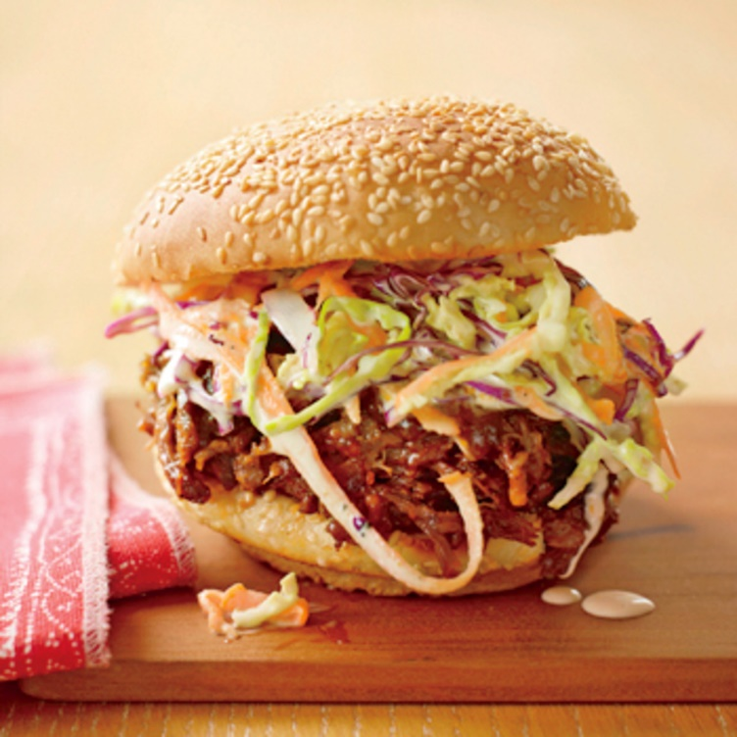
BBQ Beef Sandwich
RECIPE
INGREDIENTS
- 5 lbs. shredded pot roast
- 4 cups BBQ Sauce
- 2-quart homemade coleslaw
- 24 hamburger buns

DIRECTIONS
- Remove pot roast from plastic bag saving juice for gravy in other recipes. Shred amount needed keeping in mind that you will get at least 5 servings per pound and you’re working with a 14-pound roast. Use any beef you’re not going to use for the BBQ and use it in the frozen meal program.
- Heat shredded beef and BBQ sauce to 145º F.
- Add BBQ beef, topped with some coleslaw, on the buns

Prep Time: 30 minutes | Cook Time: 60 minutes | Total Time: 90 minutes | Yield: 24 servings

