Banana Bread
RECIPE
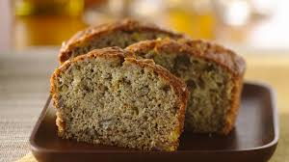
INGREDIENTS
- 2 to 3 very ripe bananas, peeled
- 1/3 cup butter, melted
- 1 teaspoon baking soda
- Pinch of salt
- 3/4 cup sugar (1/2 cup if you would like it less sweet, 1 cup if more sweet)
- 1 large egg, beaten
- 1 teaspoon vanilla extract
- 1 ½ cups flour
- Optional Ingredients:
brown sugar, cinnamon, walnuts, pecans, chocolate chips, raisins

DIRECTIONS
- Preheat the oven to 350°F, and spray loaf pan with non-stick spray.
- In a mixing bowl, mash the ripe bananas with a fork until completely smooth. Stir the melted butter into the mashed bananas.
- Mix in the baking soda and salt. Stir in the sugar, beaten egg, and vanilla extract. Mix in the flour.
- Pour the batter into your prepared loaf pan.
- Bake for 50 minutes to 1 hour or until a tester inserted into the center comes out clean.
- Remove from oven and let cool in the pan for a few minutes. Then remove the banana bread from the pan and let cool completely before serving.

Prep Time: 10 minutes | Cook Time: 55 minutes | Total Time: 65 minutes | Yield: 1 loaf

