Baked Spaghetti & Meat Sauce
RECIPE
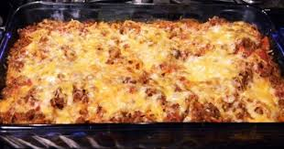
INGREDIENTS
- 2 pounds cooked spaghetti
- 5 pounds cooked ground beef
- ½ can (#10) pasta sauce
- 1 ½ cups cottage cheese
- ½ cup sour cream
- 8 ounces cream cheese
- ¼ cup milk
- ½ pound butter
- 1 pound mozzarella or cheddar cheese

Note: No need for an additional carbohydrate since the main dish includes pasta.

DIRECTIONS
- Preheat oven to 350 degrees.
- Cut half the butter into pieces and lay in the bottom of a 2” pan.
- Place half the cooked spaghetti evenly in pan.
- In mixer, combine cottage cheese, sour cream, cream cheese and milk. Spread mixture on top of spaghetti.
- Place remaining spaghetti on top of cheese mixture. Cut the remaining butter in to pieces and place on top of spaghetti.
- Mix cooked ground beef and pasta sauce, then spread sauce mixture over spaghetti.
- Cover with foil and bake approximately 30 minutes. Uncover and top with mozzarella or cheddar cheese. Bake an additional 10 minutes or until internal temperature reaches 165 degrees.

Prep Time: 30 minutes | Cook Time: 40 minutes | Total Time: 70 minutes | Yield: 32 servings

