Amish Baked Oatmeal
INGREDIENTS
- 4-1/2 cups milk (preferably anything but skim)
- 6 large eggs
- 1-1/2 cups light-brown sugar
- 3/4 cup butter, melted
- 1 tablespoon plus 1-1/2 teaspoons baking powder
- 1 tablespoon plus 1-1/2 teaspoons vanilla extract
- 1 tablespoon cinnamon
- 3/4 teaspoon salt
- 9 cups rolled oats (quick oats works fine too)
- Optional Ingredients:
Fresh fruits (berries, sliced bananas, diced apples, pears, peaches), nuts, coconut, maple syrup, honey, sweetener, chocolate chips, raisins, dried cranberries.

RECIPE

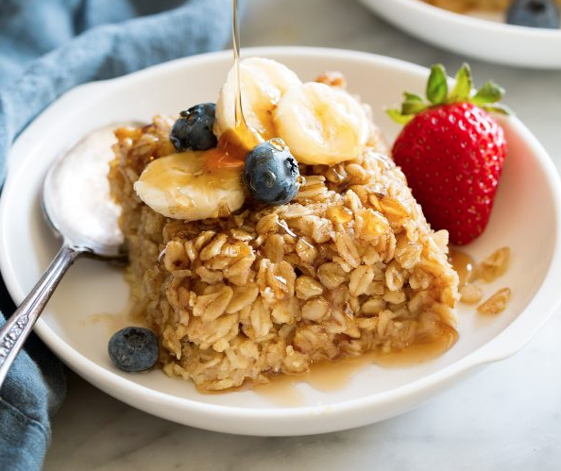

DIRECTIONS
- Preheat oven to 350 degrees. Butter three 8 by 8-inch baking dishes, set aside.
- In a large mixing bowl whisk together milk, eggs, brown sugar, butter, baking powder, vanilla, cinnamon and salt.
- Mix in oats and optional nuts, dried fruit and chocolate chips.
- Pour into prepared baking dishes and spread evenly. (Optional fresh fruit may be placed on top before or after baking).
- Bake in preheated oven 30-35 minutes until set.
- Let cool slightly then cut into squares and serve warm.

Prep Time: 10 minutes | Cook Time: 40 minutes | Total Time: 50 minutes | Yield: 24 servings

