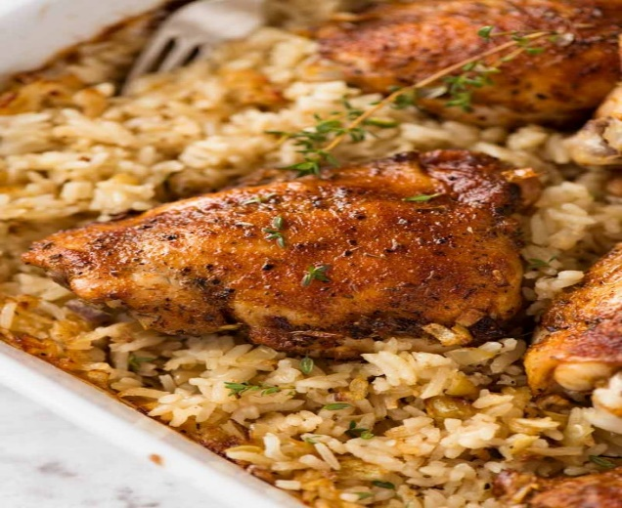
Baked Chicken and Rice
RECIPE

DIRECTIONS
- Preheat oven to 375 degrees.
- Scatter onion and garlic in a baking pan. then place butter evenly over onions and garlic. Bake for 15 minutes (check at 12 minutes, mix if some bits are browning too much).
- Meanwhile, mix together spices. Sprinkle spices on both sides of the chicken.
- Remove baking dish from the oven. Add rice then mix together with cooked garlic and onions.
- Place chicken on rice. Then pour chicken broth and water around the chicken.
- Cover with foil, then bake for 30 minutes. Remove foil, spray chicken with oil (optional), then reduce heat to 325 degrees and bake for a further 20 minutes until liquid is absorbed in rice. Internal temperature of chicken should be 165 degrees.
- Stand for 5 minutes, then remove chicken and fluff up rice. Garnish with parsley if desired, serve and enjoy!

INGREDIENTS
- 24 chicken pieces
- 4 onions, chopped
- 8 tablespoons butter, sliced
- 8 garlic cloves, minced
- 1 tablespoon paprika
- 1 tablespoon thyme
- 2 teaspoons garlic powder
- 2 teaspoons onion powder
- Salt and pepper
- 6 cups white rice
- 6 cups low sodium chicken broth
- 5 cups water
- Optional Ingredients:
brown rice, fresh parsley

Prep Time: 10 minutes | Cook Time: 70 minutes | Total Time: 80 minutes | Yield: 24 servings

