Baked Beans
RECIPE
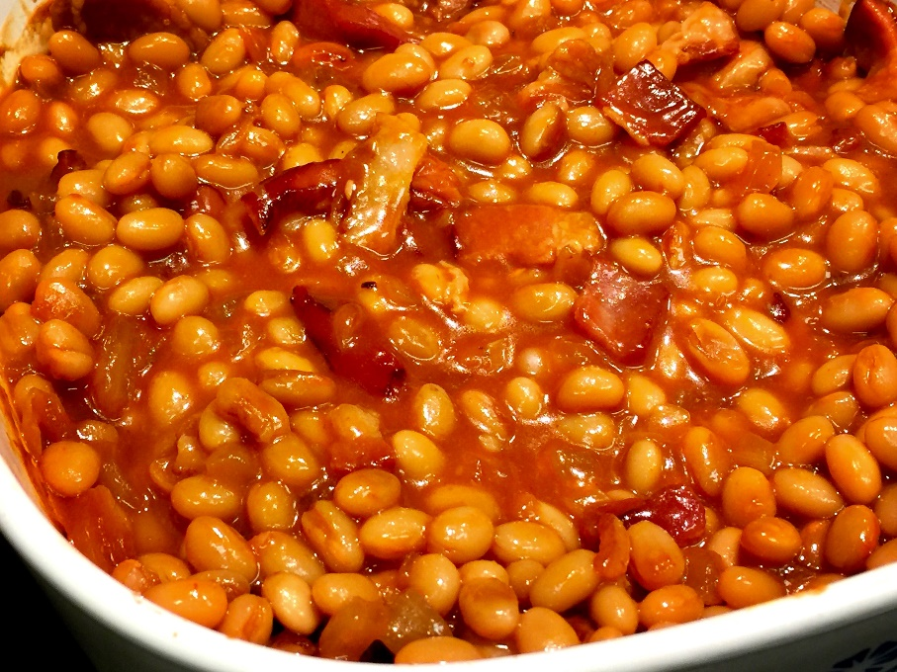
INGREDIENTS
- 1 (#10) can of pork-n-beans
- 8 slices bacon
- 1 large onion chopped
- 1 1/3 cups brown sugar
- ½ cup ketchup
- 3 tablespoons Worcestershire sauce
- 3 tablespoons yellow mustard
- Pepper to taste
- Optional Ingredients:
dry mustard, molasses, liquid smoke, garlic, green pepper

DIRECTIONS
- Fry bacon until crisp. Drain on paper towels and reserve drippings. When cooled, brake up bacon into pieces.
- Preheat oven to 350-375 degrees. Spray a 2” pan with non-stick spray.
- If desired, cook onions in a small amount of reserved bacon fat until translucent. Onions may be added raw if you do not want to cook them.
- In a large bowl, mix together beans, onions, bacon, brown sugar, ketchup, Worcestershire sauce, and mustard. Pour into prepared pan.
- Bake for 1 ½ hours. Remove from oven and let stand for a few minutes before serving.

Prep Time: 10 minutes | Cook Time: 90 minutes | Total Time: 100 minutes | Yield: 16 servings

