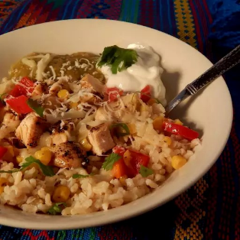 Baja-Style Chicken Bowl
For a little extra flavor, add the salsa while cooking instead of after.
Serves 25
Ingrediets

½ cup oil

15 lbs diced cooked chicken

6 cup frozen corn

12 red, yellow or green bell pepper, sliced

salt and pepper to taste

12 cup cooked brown rice

6 cup salsa

3 cup shredded Monterey Jack cheese

Directions
- Heat oil in a skillet over medium heat. Cook and stir chicken, corn, and red pepper in hot oil until heated through and pepper is slightly softened, about 5 minutes. Season with salt and pepper.
- Serve over rice and top with salsa and cheese (**you can add sour cream if you desire).

