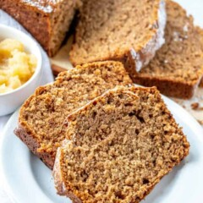 APPLESAUCE CAKE

Ingredients
1 bag spice cake mix
4 cup applesauce
1 cup water (adjust water to cake consistency)

Instructions
- Preheat oven to 350.
- Liberally spray loaf pan with non-stick cooking spray and set aside.
- Let cool slightly and sprinkle with powdered sugar or make a powder sugar glaze

Notes:
Feel free to adjust this by adding nuts or drained crushed pineapple or even 2 cans (15 oz) of pumpkin. Try adding coconut flakes. Get creative and enjoy the process.

