Amish Breakfast Casserole
RECIPE
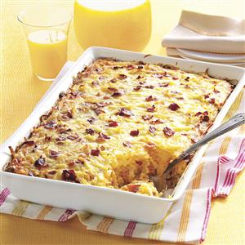
INGREDIENTS
- 3 pounds of bacon, diced
- 3 medium onions, chopped
- 18 large eggs
- 12 cups frozen hash brown, thawed
- 6 cups cheddar cheese, shredded
- 4 ½ cups cottage cheese
- 3 ¾ cups cheddar jack cheese, shredded
- Optional Ingredients:
Thyme, parsley, milk

DIRECTIONS
- Preheat oven to 350 degrees. Spray 2-3 baking dishes with non-stick spray.
- In a skillet, cook bacon and onion over medium heat until bacon is crisp; drain and set aside.
- In a large bowl add eggs and whisk. Combine hash browns and cheeses. Stir in bacon mixture and any desired optional ingredients. (May add a little milk if needed)
- Pour into prepared baking dishes.
- Bake, uncovered, at 350° for 40-50 minutes or until a knife inserted in center comes out clean. Let stand 10 minutes before cutting. (Serve with fruit or a vegetable. No need for a carbohydrate or an additional protein.)

Prep Time: 40 minutes | Cook Time: 45-50 minutes | Total Time: 85-90 minutes | Yield: 30 servings

