American Goulash
RECIPE
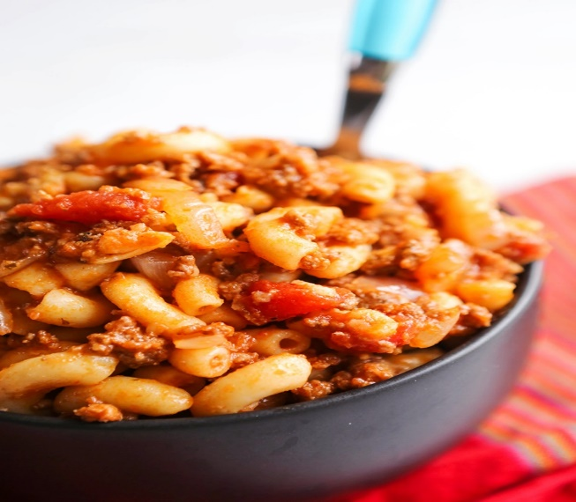
INGREDIENTS
- 6 pounds ground beef
- 6 large yellow onions, chopped
- 9 cloves garlic, minced
- 9 cups water
- 1 (#10) can tomato sauce
- 1 (#10) can diced tomatoes
- 6 tablespoons Italian seasoning
- 9 bay leaves
- 9 tablespoons soy sauce
- 3 tablespoons garlic powder
- 3 tablespoons black pepper
- 3 tablespoons seasoned salt
- 6 cups macaroni, uncooked
- Optional Ingredients:
Sugar, onion powder, mozzarella

Note: No need for an additional carbohydrate since the main dish is pasta.

DIRECTIONS
- Cook beef over medium-high heat, stirring, until browned so that ground beef crumbles and no pink remains. Drain grease.
- Add onions & garlic to the beef and sauté until they are tender, about 5 minutes
- Add water, tomato sauce, diced tomatoes, Italian seasoning, bay leaves, soy sauce, garlic powder, black pepper and seasoned salt. Stir well, cover and cook for 15-20 minutes.
- Add macaroni, stir well, cover and simmer for about 30 minutes.
- Turn off heat, remove bay leaves before serving. (If desired, place goulash in a 2” pan and top mozzarella. Place in oven to melt and brown cheese)

Prep Time: 15 minutes | Cook Time: 95 minutes | Total Time: 105 minutes | Yield: 24 servings

