Ambrosia Salad
RECIPE
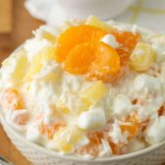
INGREDIENTS
- 3 cups sour cream
- 3 cups mini marshmallows, regular or rainbow colored
- 3 cups shredded coconut
- 3 cups pineapple tidbits, well drained
- 3 cups mandarin oranges, drained
- Optional Ingredients:
grapes, nuts, whipped cream, maraschino cherry

DIRECTIONS
- Fold together all ingredients in a large bowl. Refrigerate at least 4 hours or overnight.
- Serve cold. Garnish with a maraschino cherry (optional).

Prep Time: 10 minutes | Cook Time: 0 minutes | Total Time: 10 minutes | Yield: 24 servings

