Alpine Chicken
RECIPE
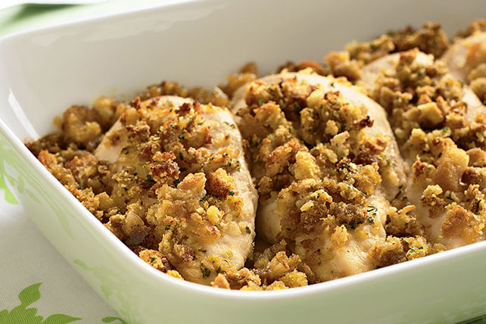
INGREDIENTS
- 24 boneless, skinless chicken breasts
- 24 Swiss cheese slices
- 4 (10.5 oz) cans Cream of Chicken soup
- 2 soup cans of milk
- 2 (14 oz) bags of seasoned stuffing mix
3 cups melted margarine
- Optional Ingredients:
low sodium chicken stock

DIRECTIONS
- Preheat oven to 350 degrees F. Spray 2” pan with non-stick spray.
- Arrange chicken in a single layer in pan. Top each piece with a slice of Swiss cheese.
- In a bowl, mix soup and milk until blended. (May use chicken stock in place of milk). Pour over chicken.
- In a bowl, toss stuffing mix with melted margarine; spread over soup mixture.
- Cover the pan with foil and bake for 45 minutes.
- Uncover and bake until stuffing is golden brown and internal temperature reaches 165 degrees.

Prep Time: 15 minutes | Cook Time: 45-60 minutes | Total Time: 60-75 minutes | Yield: 24 servings

